**-: DevOPs Introduction :-**

**DevOps Architectural Block Diagram :**

In this training we will learn about DevOps with Amazon Web Services (AWS). Concepts and Tools that will be covered in this training are : Linux OS & Shell scripting basics, Git, Jenkins, Docker, AWS ( EC2, S3, IAM), JIRA.

The word “DevOps” was coined in 2009 by Patrick Debois.

A compound of development (Dev) and operations (Ops), DevOps is the union of people, process, and technology to continually provide value to customers.

DevOps enables formerly siloed roles—development, IT operations, quality engineering, and security—to coordinate and collaborate to produce better, more reliable products. By adopting a DevOps culture along with DevOps practices and tools, teams gain the ability to better respond to customer needs, increase confidence in the applications they build, and achieve business goals faster.

*The two primary antecedents of DevOps are:*

1. Enterprise systems management (ESM) : Admins
2. Agile development : Developers (Code & Automation)

a DevOps engineer is needs to have an understanding of SDLC (Software Development Lifecycle) and of automation tools for developing CI/CD pipelines.

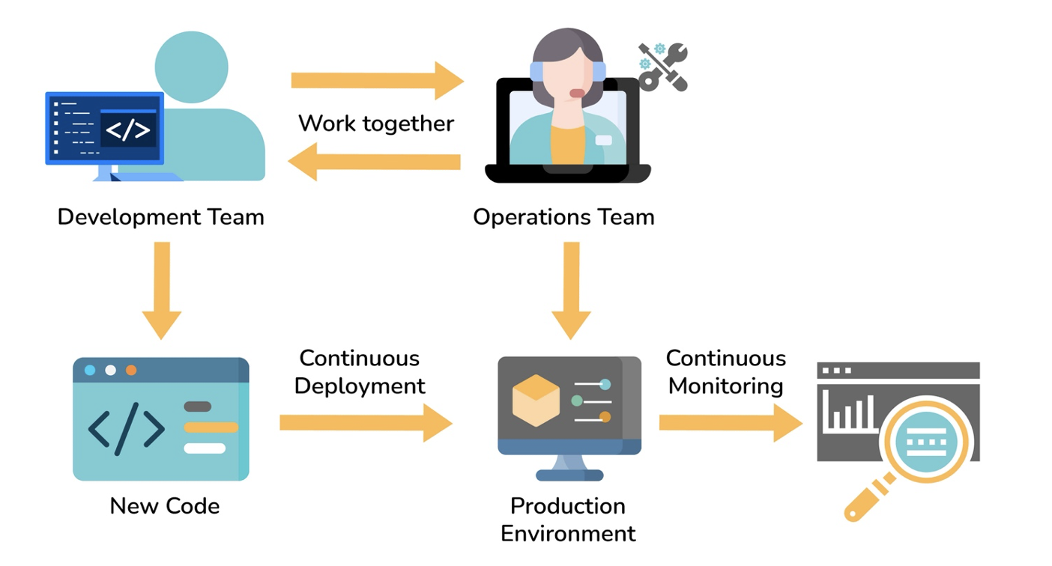

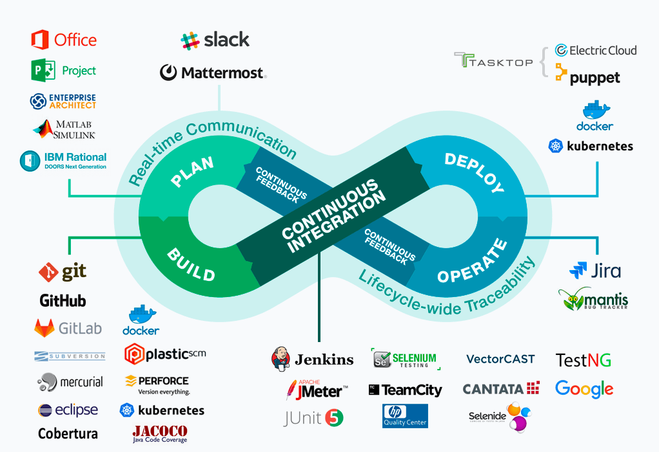

**DevOPs Practices**

1. Collaboration between teams
2. Continuous integration and continuous delivery/deployment (CI/CD)
3. Version control
4. Infrastructure as code
5. Configuration management
6. Continuous Testing and monitoring

**The Benefits of DevOPs**

* Accelerating time to market due to reduced release cycle
* Adapting to the market and competition
* Maintaining system stability and reliability
* More focus on innovation
* Early error detection – Shift left
* Improving customer experience

**DevOps Future Trends:**

Microservices architecture, DevSecOps, AI and ML Integration, Serverless architecture, IaC adoption.

**Build & Release process**

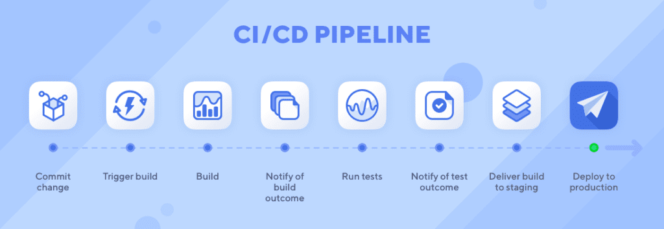

*“DevOps is not a goal, but a never-ending process of continuous improvement.”*

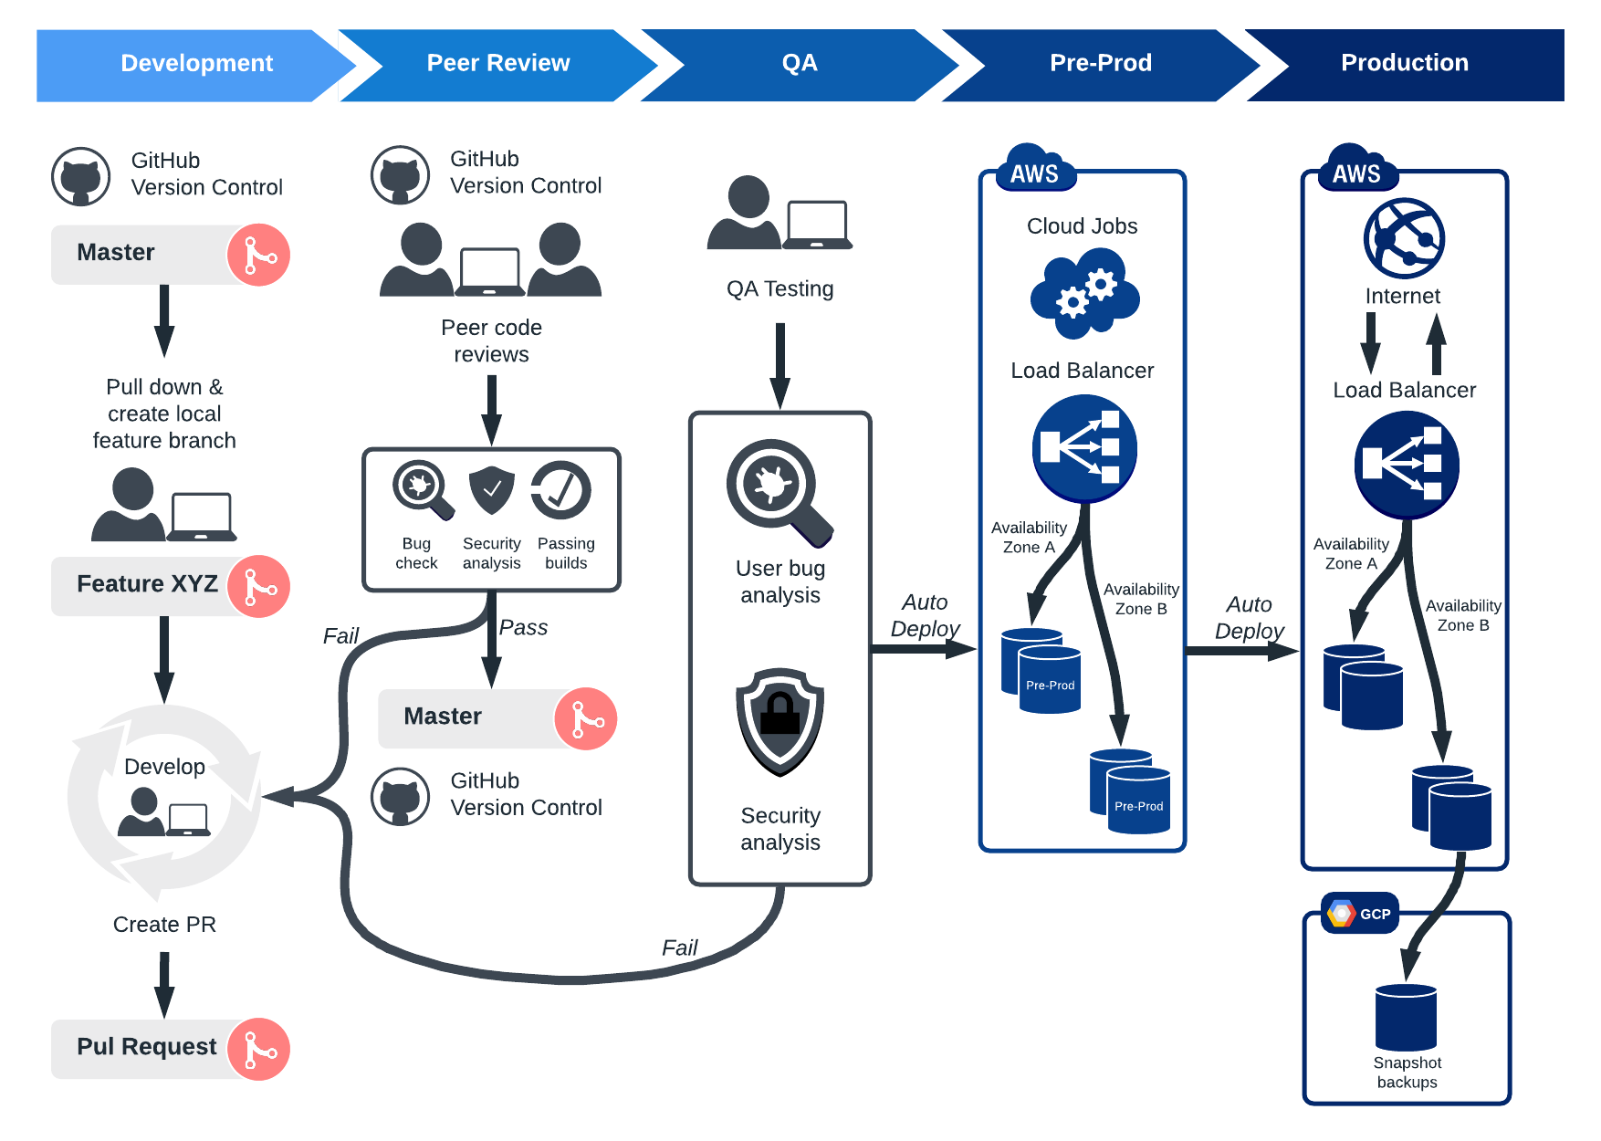

**SDLC – Software Development Life Cycle**

The **Software Product Development Life Cycle** is a framework that aligns and streamlines tasks at each phase of software development.

The purpose of adherence to the SDLC methodology is to organize product development systematically and in a disciplined way. The SDLC phases cover the complete development cycle from ideation to launch and maintenance.

Software product requirements differ based on the product’s nature, the software development life cycle has several models. However, each model has its unique features and comes with its own benefits and drawbacks.

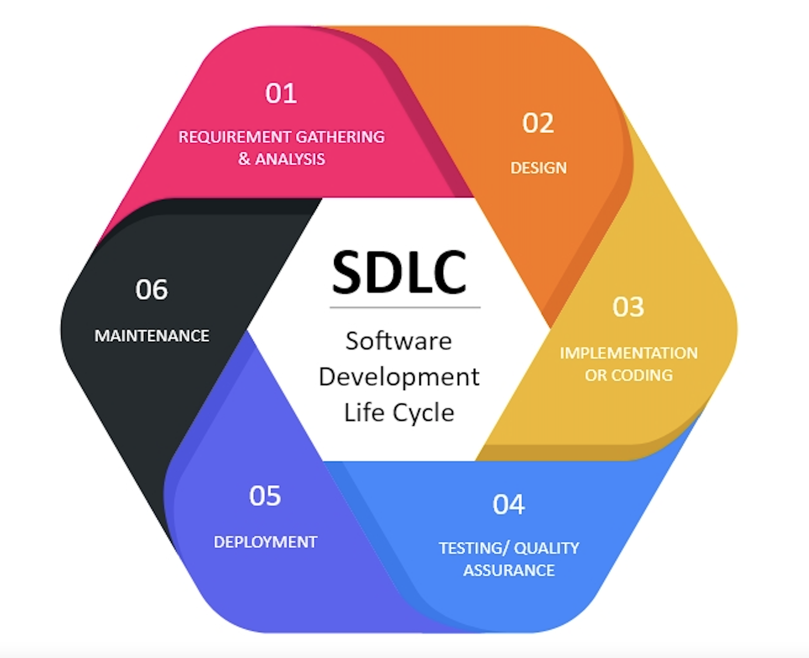

**SDLC Models:**

1. Waterfall model
2. V-Shaped model
3. Prototype
4. Spiral
5. Agile